An improved method of VF2 algorithm for directed graph isomorphism
First Author¹[0000-1111-2222-3333] and Second Author²[1111-2222-3333-4444]
¹ Princeton University, Princeton NJ 08544, USA
² Springer Heidelberg, Tiergartenstr. 17, 69121 Heidelberg, Germany
lncs@springer.com
Abstract. VF algorithm used for (sub)graph isomorphism is developed in 1999. Then in 2004, VF2, an improved algorithm in time and space complexity for VF is presented. Lately the VF3 is proposed for VF2 to improve the speed on subgraph isomorphism. In this paper, an improved method of VF2 algorithm for unbalanced directed graph isomorphism (VFD) is presented, after the first version VF, second version VF2 and third version VF3. The thought of method is inspired from the VF3. VFD algorithm is designed to reduce the time cost on the directed graph isomorphism, with the same space complexity as VF2. The details on the improvements are illustrated and then experiments used to compare the performance between the VFD and VF2, are conducted on the widely known MIVIA graph database. Finally, the conclusion that the less time with VFD is costed than that with VF2 for the directed graph isomorphism is drawn.
Keywords: VFD, VF2, unbalanced directed graph
- Introduction

In structural pattern recognition, graph is a basic description for object, which uses nodes to present the parts of the object and edges to the relationships among the parts. There are two kinds of graph operations: exact graph matching and inexact graph matching. While exact graph matching is to find the exact solution to the matching problem, inexact graph matching is to find approximate solution, which do not guarantee finding an exact and optimal solution. Graph isomorphism is belonged to the former [1]. Graph isomorphism is a NP problem. However, it is not certain whether graph isomorphism is P problem. And it is also not certain whether graph isomorphism is NP-complete. Recently, the conclusion that graph isomorphism problem can be solved in Quasipolynomial (exp((log n)^{O(1)}) time is presented by László Babai from University of Chicago, after updating from 2015 to 2017[2]. The paper has not been fully peer-reviewed now. There are several ways to solve the problem: (1) brute force matching algorithms, whose time requirements increase exponentially with the size of the input graphs, restricting the applicability of graph based techniques to problems implying graphs with a small number of nodes and edges; (2) specified algorithms designed for specified graphs, which reduces the computational complexity of the matching process by imposing to topological restrictions on the graphs [3][4][5][6]. However, the method cannot be applied in general cases;(3) backtracking algorithms which reduce the matching complexity by using an adequate representation of searching process and pruning unprofitable paths in the search space, including SD algorithm designed by Schmidt and Druffel[7], Ullmann algorithm presented by Ullmann[8], a series algorithms of VF, VF2, VF3 proposed by Mario Vento, et al[9][10][11]; (4) canonical algorithms, which reduce the graphs to be matched to a canonical form by a set of transformation and then judge that the given graphs is whether isomorphism, including Nauty algorithm presented by McKay[12][13], Saucy algorithm introduced by Darga et al.[14], Bliss algorithm presented by Juntilla and Kaski[15][16].(5) parameterized algorithms, including Graph Linearization Algorithm(GLA) introduced by Juan Mendivelso et al[17]. Among the above algorithms, Ullmann algorithm and the series algorithms of VF, VF2, VF3 not only are used for graph isomorphism, but also for subgraph isomorphism. VF2 is the best algorithm compared to Ullmann algorithm, SD algorithm, VF algorithm and Nauty algorithm in most cases except for the larger randomly connected graphs [18]. To solve the problem, the authors improve the performance on the larger randomly connected graphs by using stronger rules which are designed for the directed graphs. Finally, in order to provide an assessment of the improvements, we compared VFD with VF2 algorithms on the kinds of graphs: randomly connected graphs, 3D meshes in MIVIA datasets [19] [20].
The paper is organized as follows: In Section 2, some basics and a short description of the series algorithms of VF, VF2, VF3 are presented. Then improvements are detailed in Section 3. Section 4 is devoted to algorithm testing and comparative analysis of the obtained results. Final conclusions are in Section 5.
- Preview
Before starting the description of the improvements in VF2, it is important to provide some basis about graph, graph isomorphism and introduce the development of the series algorithms of VF, VF2, VF3. These could have us more familiar with the VFD designed by the authors.
  - Basic
The definition of graph is first basic to know and it’s given here [21]:
A graph is a 4-tuple G=( $V, E, α, β$), where
- V is the finite set of vertices
- E$⊆$ V $×$V is the set of edges
- $α$: V$→$L is a function assigning labels to the vertices
- $β$: E$→$L is a function assigning labels to the edges
After the definition of graph, graph isomorphism is following here [22]. Informally, Graph isomorphism is to decide if two given graphs are equivalent in terms of structure and labels. The following is given as its formal definition:
Let G₁ = ( $V_{1}, E_{1}, α_{1}, β_{1}$) and G₂ = ( $V_{2}, E_{2}, α_{2}, β_{2}$) be two graphs. A graph isomorphism between G1 and G2 is a bijection $φ: V_{1}→V_{2}$ satisfying
- $α_{1}\left(v\right)= α_{2}(φ\left(v\right))$, $∀ v∈V_{1}$
- $∀ e_{1}=(μ, v)∈E_{1}$, there exists an edge $e_{2}=(φ(μ),φ( v))∈E_{2}$ such that $β_{1}($ $e_{1})= β_{2}( e_{2})$
- $∀ e_{2}=(μ, v)∈E_{2}$, there exists an edge $e_{1}=(φ^{-1}(μ),φ^{-1}( v))∈E_{1}$ such that $β_{1}($ $e_{1})= β_{2}( e_{2})$
Two graphs are called isomorphic if there exists an isomorphism $φ(∙)$ between them.
The definition of state space representation(SST) is the last one but most important. State space representation is used to describe a graph matching process. Given the graph G₁ = ( $V_{1}, E_{1}, α_{1}, β_{1}$) and G₂ = ( $V_{2}, E_{2}, α_{2}, β_{2}$), each state$s$, in the state space S, represents a partial mapping M(s) between $V_{1}$ and $V_{2}$, that involves only a subset of all the node couples in the goal mapping M. Each partial mapping M(s) =M₁ ($s$)$×$M₂ ($s$) is composed of a set of ordered node couples ($μ, v$), where $μ$ $∈$ M₁(s)$⊆$ $V_{1}$ and $v$ $∈$ M₂ ($s$)$⊆$ $V_{2}$. The matching process is a search inside the SSR where the algorithm starts from initial state $s_{0}$, that represents a void mapping M ($s_{0}$)=$∅$ and searches for one or more goal states $s_{i}$, where M ($s_{i}$)=M. Each new state $s^{'}$is generated from a parent state $s$ by adding a new ordered couple ($μ, v$) to M $(s)$, where $μ, v$ $∉M\left(s\right).$ The state transition from s to $s^{'}$ corresponds to the addition of the node $μ$ to M₁ ($s)$and the node $v$ to M₂($s)$ [23].
For understanding the above definition, an example is given [1]. Fig.1a is two graphs which are isomorphic. As illustrated in Fig. 1b, the resolution process in SSR is represented by a tree, whose states represents partial solutions by the corresponding mappings M ($s_{i}$), where
M₁ ($s_{0}$)= M₂ ($s_{0}$)={0}
M₁ ($s_{1}$) = {1} M₂ ($s_{1}$) = {A}
M₁ ($s_{5}$) = {1, 2} M₂ ($s_{5}$) = {A, B}
M₁ ($s_{8}$) = {1, 2, 3} M₂ ($s_{8}$) = {A, B, C}
M₁ ($s_{10}$) = {1, 2, 3, 4} M₂ ($s_{8}$) = {A, B, C, D}
And Fig. 1c reports the partial solution in terms of graphs associated to state $s_{8}$.
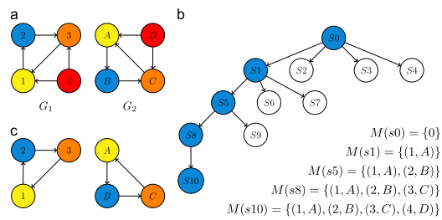
Fig. 1. (a) Graph isomorphism between $G_{1}$ and $G_{2}$. (b) The resolution process in SSR is represented by a tree, whose states represent feasible partial solution (i.e. isomorphic) by the corresponding mappings M ($s_{i}$). (c) The partial solution associated to $s_{8}$[1].
  - VF, VF2, VF3 algorithms
VF algorithm is introduced by L.P. Cordella, et al in 1999, which is used for directed graphs [9]. So do undirected graphs, as undirected graphs can be transferred into directed graphs. Directed graph includes two basic relationships between nodes: predecessor and successor. If there exists an edge from $m$ pointed into $n$, then $m$ is named as predecessor of n and n as successor of $m$. Nodes in graphs during matching process are classified into five class:
  - $M_{i}$ ($s$): nodes in partial solutions for graph $i$ in s state
  - $T_{i}^{in}$($s$): nodes that are predecessor of nodes in $M_{i}$(s)
  - $T_{i}^{out}$($s$): nodes that are successor of nodes in $M_{i}$(s)
  - ${New}_{i}$ ($s$): nodes that are not adjacent to nodes in $M_{i}$(s)
  - ${next_node}_{i}$: node selected for next state $s^{'}$
Where $i ∈$ {1, 2}.
According to those class, some rules are made for ${next_node}_{i}$ selection and to judge whether they are to be added into $M_{i}$ ($s$) and generated next new state $s^{'}$. For the rule of ${next_node}_{i}$selection, it is selected from candidate set P(s)=$T_{i}^{out}$($s$)$∪$ $T_{i}^{in}$($s$)$∪{New}_{i}. T_{i}^{out}$($s$) is the first to select; If there are no nodes to select, then it is chose from $T_{i}^{in}$($s$); ${New}_{i}$ is the last one to be chose. When ${next_node}_{i}$ is given and added into $M_{i}$ ($s$), the predecessor nodes of ${next_node}_{i}$ are added into $T_{i}^{in}$($s$) and the sucessor nodes of ${next_node}_{i}$ into $T_{i}^{out}$($s$). For the rule of ${next_node}_{i}$judgement, there are five feasibility rules:
- Iff for each predecessor $n_{1}^{'}$ of ${next_node}_{1}$ in the in $M_{1}$ ($s$), there exists a $n_{2}^{'}$ belonged to $M_{2}$ ($s$) which are predecessor of ${next_node}_{2}$.
- Iff for each successor $n_{1}^{'}$ of ${next_node}_{1}$ in the in $M_{1}$ ($s$), there exists a $n_{2}^{'}$ belonged to $M_{2}$ ($s$) which are successor of ${next_node}_{2}$.
- Iff the number of predecessors and successors of ${next_node}_{1}$ that are in $T_{1}^{in}$($s$) (Termin1) is equal to the number of predecessors and successors of ${next_node}_{2}$ that are in $T_{2}^{in}$($s$) (Termin2).
- Iff the number of predecessors and successors of ${next_node}_{1}$ that are in $T_{1}^{out}$($s$) (Termout1) is equal to the number of predecessors and successors of ${next_node}_{2}$ that are in $T_{2}^{out}$($s$) (Termout2).
- Iff the number of predecessors and successors of ${next_node}_{1}$ that are in ${New}_{1}(s)$ (Termnew1) is equal to the number of predecessors and successors of ${next_node}_{2}$ that are in${New}_{2}(s)$ (Termnew2).
Finally, VF algorithm terminate the current state $s$ by the inequality between the number of nodes (n1 $≠$n2) or between the size of $T_{i}^{out}$($s$) (Out_len1$≠$ Out_len2) or between the size of $T_{i}^{in}$($s$) (In_len1$≠$ In_len2)
After having those rules, VF algorithm can prune unprofitable paths in the search space, and quickly finish the matching. The matching algorithm is given here:
PROCEDURE Match(s)
INPUT: an intermediate state $s$; the initial state$s_{0}$ has $M$($s_{0}$)=$∅$
OUPUT: the mappings between the two graphs

IF M(s)covers all the nodes THEN
OUTPUT M(s)
IF M(s)is dead THEN
RETURE FALSE
ELSE
Compute the candidate set P(s)
FOREACH p$∈$P(s)
IF the feasibility rules succeed for p
THEN
Compute the new state $s^{'}$ obtained by adding by p
to M(s)
CALL $Match$($s^{'}$)
END IF
END FOREACH
END IF
END PROCEDURE
In VF algorithm, there have to be four arrays whose length are number of nodes. So, it has the space complexity of $O(n^{2})$, which also increase the time cost to some extent.
In 2004, Luigi P. Cordella, Pasquale Foggia, et al. developed VF2 to improve the performance by a well-devised data structures and adding some new rules into VF algorithm. There are just six arrays whose length are number of nodes during the matching process by designing a new restore function BackTrack(). So, it has the space complexity of $O(n)$. For the rule of ${next_node}_{i}$selection, VF2 algorithm select it from the intersection $T_{i}^{both}$($s$) between $T_{i}^{out}$($s$) and $T_{i}^{in}$($s$) firstly. The following candidates are $T_{i}^{out}$($s$), $T_{i}^{in}$($s$), ${new}_{i}$ in proper order. For rule of terminating current state, the judgement on the size of $T_{i}^{both}$($s$) (Both_len1 $≠$ Both_len2) is added.
In 2015, VF3 is presented by Vincenzo Carletti et al., which uses the new Total Order Relationship and divides nodes according the labels of nodes [12]. The improvements are designed for attribute graphs on subgraph matching. VF3 has shown to be competitive with RI and VF2.
- Improvements
With the development of the series algorithms of VF, VF2, VF3, there are continuously improvements. However, VF2 play a more important role in dealing with graph isomorphism and subgraph isomorphism, with its remarkable performances improvements in space and time cost. VF3 is just designed for attribute graphs, which does not change the data structures used in VF2. In these three algorithms, the rule of ${next_node}_{i}$judgement is the same. However, the third feasibility rule detailed in Section 2.2 has a problem for directed graphs. When the ${next_node}_{i}$ is satisfied to this rule, it does not guarantee the number of predecessors (or successors) of ${next_node}_{1}$ that are in $T_{1}^{in}$($s$) is equal to the number of predecessors (or successors) of ${next_node}_{2}$ that are in $T_{2}^{in}$($s$) in the current state $s$. It is not until getting into next state $s^{'}$ that the above case will be judged by terminal function in the next state $s^{'}$. Neither do the fourth and fifth feasibility rules. So, these rules can be perfected to judge the case in current state by refining them, as a result of change for terminal function that judge whether to terminate current state.

  - Feasibility Rules
To solve the problem mentioned above, the last three feasibility rules are refined, with remaining the first feasibility rules unchanged. The last feasibility rules are divided into six rules:
- the number of predecessors of ${next_node}_{1}$ that are in $T_{1}^{in}$($s$) (Termin1_in) is equal to the number of predecessors of ${next_node}_{2}$ that are in $T_{2}^{in}$($s$)( Termin2_in).
- the number of successors of ${next_node}_{1}$ that are in $T_{1}^{in}$($s$) (Termin1_out) is equal to the number of successors of ${next_node}_{2}$ that are in $T_{2}^{in}$($s$)( Termin2_out).
- the number of predecessors of ${next_node}_{1}$ that are in $T_{1}^{out}$($s$) (Termout1_in) is equal to the number of predecessors of ${next_node}_{2}$ that are in $T_{2}^{out}$($s$)( Termout2_in).
- the number of successors of ${next_node}_{1}$ that are in $T_{1}^{out}$($s$) (Termout1_out) is equal to the number of successors of ${next_node}_{2}$ that are in $T_{2}^{out}$($s$)( Termout2_out).
- the number of predecessors of ${next_node}_{1}$ that are in ${New}_{1}$($s$) (New1_in) is equal to the number of predecessors of ${next_node}_{2}$ that are in ${new}_{2}$($s$)( New2_in).
- the number of successors of ${next_node}_{1}$ that are in ${New}_{1}$($s$) (New1_out) is equal to the number of successors of ${next_node}_{2}$ that are in ${New}_{2}$($s$)( New2_out).
Although there are extra six variables than VF2, it can make the rules stronger prune the unprofitable paths in the search space with high efficiency. It is worth using the following rules instead of the feasibility rules 5, 6:
- the number of nodes which are the processor of ${next_node}_{1}$ (|In₁|) is equal to the number of the processor of the processor of ${next_node}_{2}$ (|In₂|).
- the number of nodes which are the successor of ${next_node}_{1}$ (|Out₁|) is equal to the number of the processor of the successor of ${next_node}_{2}$ (|Out₂|).
There is the following relationship among the |${In}_{i}$|, |In_$M_{i}$ ($s$)|, ${Termin}_{i}$_in, ${Termout}_{i}$_in and ${New}_{i}$_in.
|${In}_{i}$| =|In_$M_{i}$ ($s$)| + ${Termin}_{i}$_in + ${Termout}_{i}$_in + ${New}_{i}$_in $i∈\{1, 2\}$ (1)
If |${In}_{1}$| = |${In}_{2}$|, |In_$M_{1}$ ($s$)| = |In_$M_{2}$ ($s$)|, Termin1_in = Termin2_in and Termout1=Termout2_in, there must exists New1_in=New2_in. So do the |${Out}_{i}$|, |Out_$M_{i}$ ($s$)|, ${Termin}_{i}$_out, ${Termout}_{i}$_out and ${New}_{i}$_out. Therefore, feasibility rules 5, 6 can be replaced by 7, 8 respectively. As the |${In}_{i}$| and |${Out}_{i}$| can be get directly without calculation, there are just extra four variables to calculate. Although new rules add some calculation, it can prune the unprofitable paths in current state instead of next state. This can improve the performance of algorithm.
  - Terminal Function
With the changes of feasibility rules, there are some improvements that can be done in terminal function which judge whether to terminate the current state. As known in Section 2.2, there are four rules to follow in VF2. If n1 $≠$n2 or Both_len1 $≠$ Both_len2 or Out_len1$≠$ Out_len2 or In_len1$≠$ In_len2, current state will be terminated.
In the new algorithm, these rules can be reduced into n1 $≠$n2 or Both_len1 $≠$ Both_len2.
At the initial state $s$₀, there exist the following relationships:
Out_len1₀ = Out_len2₀ (2)
Assume at the state $s$_{k} (k >=0), there exist the following relationships:
Out_len1_{k} = Out_len2_{k} (3)
Then at the state $s$_{k+1} (k >=0),
Out_len1_{k+1} = Out_len1_{k} + New1_out_{k} (4)
Out_len2_{k+1} = Out_len2_{k} + New2_out_{k} (5)
If $s$_{k} can be transferred into $s$_{k+1}, there must exists New1_out_{k} = New2_out_{k} according to the Section 3.1. Therefore,
Out_len1_{k+1} = Out_len2_{k+1} (6)
With the same way, there is In_len1_{k} = In_len2_{k} at the state $s$_{k}. As shown above, it is no sense to judge the relationships between the size of $T_{1}^{out}$($s$) and $T_{1}^{out}$($s$) or between the size of $T_{1}^{in}$($s$) and $T_{2}^{in}$($s$). Some improvements of performance can be get from this.
New algorithm does not increase the space complexity, while it can make the matching process faster just by refining some feasibility rules and reducing the rules in terminal function.
- Experiments
To test the new algorithm, an implementation of VFD is designed based on the VF2 algorithm source code (http://mivia.unisa.it/datasets/graph-database/vflib/). Then VF2 and VFD are used to verify the efficiency of New algorithm on randomly connected graphs (rand graph data), irregular m3D meshes (m3D graph data) in MIVIA graph database [19] [20]. The larger graph data that belong to the above two categories data are generated using generators sources offered in http://mivia.unisa.it/datasets/graph-database/arg-database/. Not all graph data are tested in experiments, there are just six couples each size. Here are the details related to experiment data (Table 1).
Table 1. The classes of graph data and its sizes
rand | r001 | 200 | 400 | 600 | 800 | 1000 | 1100 | 1200 | … | 2700
rand | r005 | 200 | 400 | 600 | 800 | 1000 | 1100 | 1200 | … | 2700
rand | r01 | 200 | 400 | 600 | 800 | 1000 | 1100 | 1200 | … | 2700
m3D | m3D | 216 | 343 | 512 | 729 | 1000 | 1331 | 1728 | 2197 | *
m3D | m3Dr2 | 216 | 343 | 512 | 729 | 1000 | 1331 | 1728 | 2197 | *
m3D | m3Dr4 | 216 | 343 | 512 | 729 | 1000 | 1331 | 1728 | 2197 | *
m3D | m3Dr6 | 216 | 343 | 512 | 729 | 1000 | 1331 | 1728 | 2197 | *
In experience, every couple are tested for ten times and the authors take the average result as its real result. we will try to evaluate the time reduction of matching times which do not include time spent constructing graphs. As shown in fig. 2, the reduction of matching time increases with the number of nodes increasing on the three classes (r001, r005, r01) included in rand graph data. Fig. 3 shows the same tendency on the category of m3D graph data except for the class of m3D graph data. It is resulted by the reason that the class of m3D graph data are more regular. With the random edges increase in m3Dr2, m3Dr4, m3Dr6, the VFD algorithm do better in them.
Tests above have been carried out on Inter(R) Core(TM) i5-3470 CPU @ 3.20 GHz 3.2GHz with 8.00 GB of RAM under Windows 10Pro x64. The software used has been developed in C++ under Visual Studio 2012.

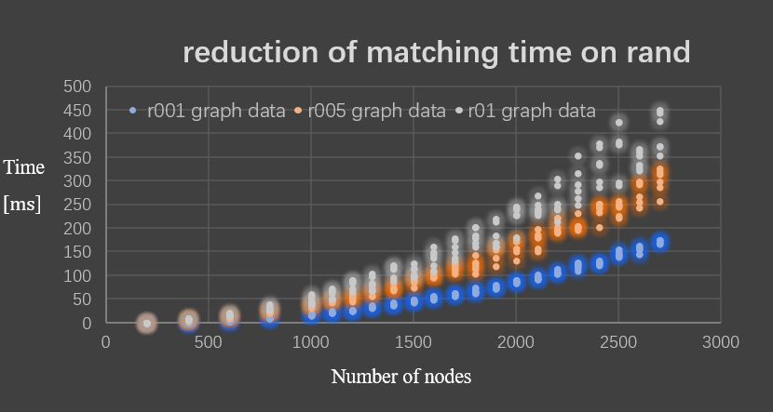
Fig. 2 reduction of matching time on rand graph data

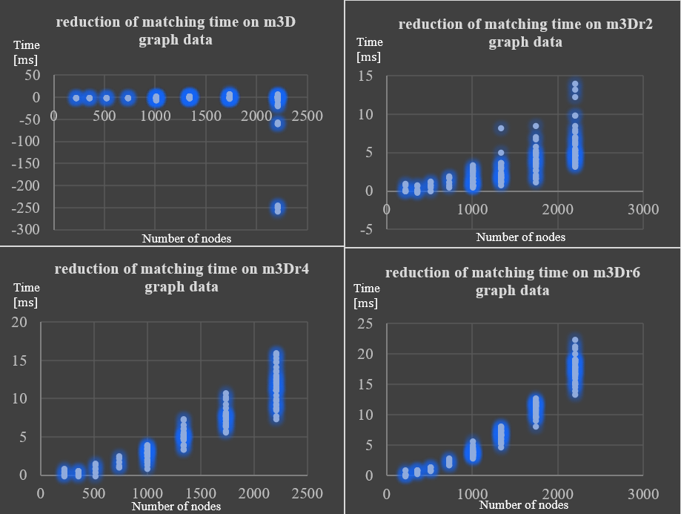
Fig. 3 reduction of matching time on m3D graph data
- Conclusions
In this paper, an improved method of algorithm VF2 is presented, namely VFD. The effectiveness of the proposed improvements has been shown by comparing VF2 with VFD, which has shown to be competitive with VF2 in graph isomorphism on random graphs. With the size of graph increasing, the reduction of matching time is increasing. Since subgraph isomorphism in VF2 has the same data structure and similar algorithm, we will extend the rules in VFD to the subgraph isomorphism in VF2 in order to obtain a better performance in the future works.
Finally, I would like to express my special appreciation my friends Jian Xu, Qiuhui Tong and my advisor Bo Yuan who give me some useful suggestions. In the meanwhile, and thanks for MIVIA offering the VF2 source code.

References
- Vento M., F.: A long trip in the charming world of graphs for pattern recognition [J]. Pattern Recognition, 48(2): 291-301 (2015).
- László Babai's Homepage, http://people.cs.uchicago.edu/~laci/, last accessed 2017/01/09.
- Aho A. V., Hopcroft J., F.: The design and analysis of computer algorithms[M]. Pearson Education India. (1974).
- Hopcroft J. E., Wong J. K., F.: Linear time algorithm for isomorphism of planar graphs (preliminary report) In: Proceedings of the sixth annual ACM symposium on Theory of computing. ACM, pp. 172-184. (1974).
- Luks E. M., F.: Isomorphism of graphs of bounded valence can be tested in polynomial time[J]. Journal of computer and system sciences, 25(1): 42-65 (1982).
- Jiang X., Bunke H., F.: Including geometry in graph representations: A quadratic-time graph isomorphism algorithm and its applications[J]. Advances in Structural and Syntactical Pattern Recognition, 110-119 (1996).
- Schmidt D. C., Druffel L. E., F.: A fast backtracking algorithm to test directed graphs for isomorphism using distance matrices[J]. Journal of the ACM (JACM), 23(3): 433-445 (1976).
- Ullmann J. R., F.: An algorithm for subgraph isomorphism[J]. Journal of the ACM (JACM), 23(1): 31-42 (1976).
- Cordella L. P., Foggia P., Sansone C., et al, F.: Evaluating Performance of the VF Graph Matching Algorithm. In: Proc. of the 10th Int. Conf. on Im. Anal. and Process., pp. 1172-1177. IEEE Computer Society Press (1999).
- Cordella L. P., Foggia P., Sansone C., et al., F.: A (sub) graph isomorphism algorithm for matching large graphs[J]. IEEE transactions on pattern analysis and machine intelligence, 26(10): 1367-1372 (2004).
- Carletti V., Foggia P., Vento M., F.: VF2 Plus: An Improved version of VF2 for Biological Graphs. In: International Workshop on Graph-Based Representations in Pattern Recognition, pp. 168-177. Springer International Publishing (2015).
- McKay B D., F.: Practical graph isomorphism[J]. (1981).
- McKay B. D., Piperno A., F.: Practical graph isomorphism. II[J]. Journal of Symbolic Computation, 94-112 (2014).
- Darga P. T., Sakallah K. A., Markov I. L., F.: Faster symmetry discovery using sparsity of symmetries. In: Design Automation Conference, 2008. DAC 2008. 45th ACM/IEEE. IEEE, pp. 149-154 (2008).
- Junttila T., Kaski P., F.: Engineering an efficient canonical labeling tool for large and sparse graphs. In: Proceedings of the Ninth Workshop on Algorithm Engineering and Experiments (ALENEX), pp. 135-149. Society for Industrial and Applied Mathematics (2007).
- Junttila T., Kaski P., F.: Conflict propagation and component recursion for canonical labeling. In: Theory and Practice of Algorithms in (Computer) Systems, pp. 151-162. Springer Berlin Heidelberg (2011).
- Mendivelso J., Kim S., Elnikety S., et al., F.: Solving graph isomorphism using parameterized matching. In: International Symposium on String Processing and Information Retrieval, pp. 230-242. Springer International Publishing (2013).
- Foggia P., Sansone C., Vento M. A., F.: performance comparison of five algorithms for graph isomorphism. In: Proceedings of the 3rd IAPR TC-15 Workshop on Graph-based Representations in Pattern Recognition, pp. 188-199. (2001).
- De S. M., Foggia P., Sansone C., et al., F.: A large database of graphs and its use for benchmarking graph isomorphism algorithms[J]. Pattern Recognition Letters, 24(8): 1067-1079 (2003).
- Foggia P., Sansone C., Vento M., F.: A database of graphs for isomorphism and sub-graph isomorphism benchmarking. In: Proc. of the 3rd IAPR TC-15 International Workshop on Graph-based Representations, pp. 176-187. (2001).
- Conte D., Foggia P., Sansone C., et al., F.: How and why pattern recognition and computer vision applications use graphs. In: Applied Graph Theory in Computer Vision and Pattern Recognition, pp. 85-135. Springer Berlin Heidelberg (2007).
- Livi L., Rizzi A., F.: The graph matching problem[J]. Pattern Analysis and Applications16(3), 253-283 (2013).
- Carletti V., F.: Exact and Inexact Methods for Graph Similarity in Structural Pattern Recognition PhD thesis of Vincenzo Carletti[D]. Université de Caen; Universita degli studi di Salerno (2016).

